Anna University Regional Campus Coimbatore

Anna University: Chennai-600 025

DEPARTMENT OF ELECTRONICS AND COMMUNICATION ENGINEERING



IBM Naan Mudhalvan Phase 2 Submission

**Title**: **AIR QUALITY ANALYSIS AND PREDICTION IN TAMILNADU**

Name : ADSHAYA B R

Department : ECE

Sem/year :5th sem 3rd year

Air Quality Analysis and Prediction in Tamil Nadu

**Objective:**

The Objective of the project is to analyze and visualize the air quality data from the various monitoring stations in Tamil Nadu. The give dataset contains the measurements of the various gases that release into the atmosphere. Some of the gases that given in the dataset are Sulphur Dioxide(SO2), Nitrogen Dioxide(NO2) and Respirable particulate matter and these are measured in different cities, villages, towns. This Project aim is to gain the insight of air pollution trends, estimate the RSPM/PM10 levels based on SO2 and NO2 levels

**Description of dataset:**

The link for the chosen dataset is mentioned below,

[https://tn.data.gov.in/resource/location-wise-daily-ambient-air-quality-tamil-nadu-year-2014](https://tn.data.gov.in/resource/location-wise-daily-ambient-air-quality-tamil-nadu-year-2014indias-state-wise-air-quality-data-tamil-nadu)

The above dataset contains the combined version of air quality of Tamil Nadu. This contains the district wise dataset for the prediction of air quality parameter in the state of Tamil Nadu. This data was released by the Ministry of Environment and Forests and Central Pollution Control Board of India under the National Data Sharing and Accessibility Policy.

Explanation:

The given dataset contains the different columns with their specific details. The different columns are **“stn code, sampling date, state, city/town, Location of monitoring stations, Agency, Type of location, SO2, NO2, RSPM/PM, SPM”**

To further proceeding of the project let us drop the unwanted columns that is unnecessary for analysis of the air quality in Tamil Nadu

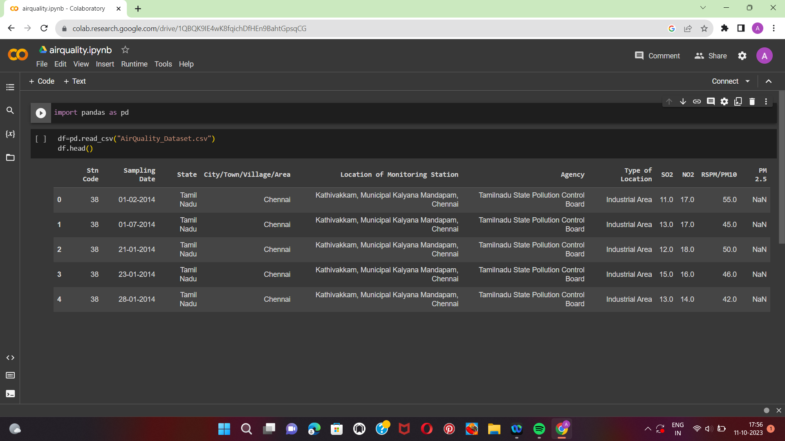

Flow Chart for the proposed system



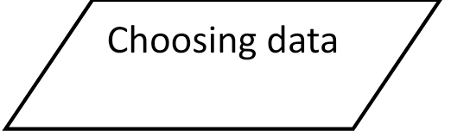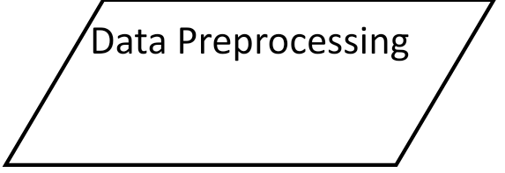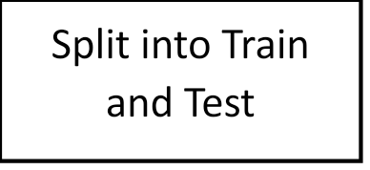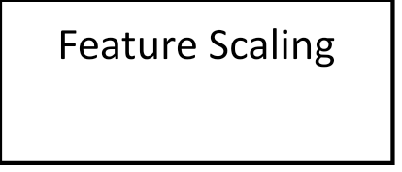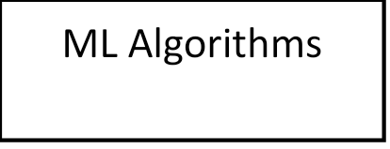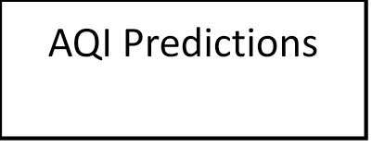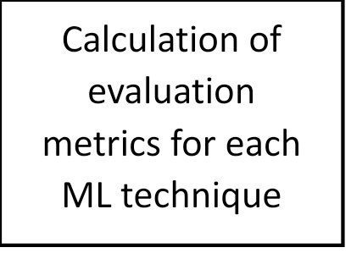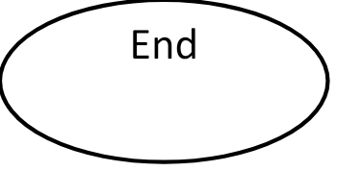

**Conclusion:**

In Conclusion, this project focuses on analysing and predicting air quality in Tamil Nadu is going to yield the valuable insights and outcomes. Through the collection and analysis of historical air quality data, we are able to identify the trends, seasonal variations, and the impact of various factors and air quality. Our predictive model, based on Machine learning algorithms, demonstrated reasonable accuracy in forecasting air quality levels.